PROJECT DOCUMENTATION
Title: Content Based Question Answering System
Objective:
To build a Python-based system that can:
- Take a paragraph of text as input.
- Accept user questions based on that content.
- Return the most relevant sentence as the answer.
Technologies:
- Python
- NLTK(Natural Language Toolkit)
- Numpy
- Scikit-Learn
Working:
- Input: A paragraph (about CTC Tech Services) and user’s question.
- Text Preprocessing:
  - Sentence tokenization: Conversion of paragraph into tokens of sentences
  - Word tokenization: Converts sentences into token of words
  - Lowercasing, stopword removal, and stemming
- TF-IDF Vectorization:
  - Term Frequency : How often a word appears.
  - Inverse Document Frequency : How unique the word is across the text.
  - Converts all sentences and the question into numerical vectors based on term frequency-inverse document frequency.
- Cosine Similarity:
  - Cosine similarity is a measure of how similar two vectors are.
  - A value of 1 means "exactly same", and 0 means "completely different".
  - Compares the question vector with each sentence vector to calculate similarity.

- Answer Extraction:
  - The sentence with the highest similarity score is selected and returned as the answer.
Sample Input:
Question: What are the services provided by CTC?
Sample Output:
Answer: They offer a wide range of services including custom software development, cloud migration, cybersecurity, data analytics, product design, and IT consulting.

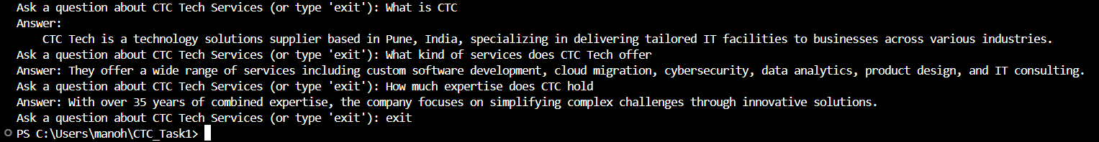
Limitations:
Keyword based system works well for only factual questions with answers in the paragraph.
Conclusion:
This project demonstrates a basic NLP-based system capable of understanding and answering content-related questions using techniques like TF-IDF and cosine similarity.

